The Malachite Marmoset: the first photosynthetic animal?

Hanuman, S. and Anjaneya, L.

Introduction

It is generally accepted that plants and animals differ fundamentally in their mode of nutrition: autotrophy versus heterotrophy. While examples of wholly or partly heterotrophic plants have been known for a long time (e.g. carnivorous plants), and there are also some animals that derive their carbon entirely from chemo-autotrophic endosymbionts (Fisher et al., 1989), a truly autotrophic multi-cellular animal has never been described. Indeed Rashevsky (1971) has argued that energetic considerations make a photo-autotrophic, mobile and terrestrial animal highly improbable: the amount of surface area required to absorb sufficient energy to allow for both body maintenance and directed movement would preclude the type of body architecture required for land-based locomotion. He shows for example (Rashevsky, 1971) that a horse whose skin had the energy absorption capabilities of a leaf could only support itself if its external surface area was one hectare!

The green-skinned Malachite Marmoset, recently discovered in the Trans-Himalaya region of the Indian state of Sikkim (Hanuman et al., 2005), has therefore raised many questions. In summer, these animals inhabit the high, grassy slopes well above the tree- and shrub-line, where they spend the entire day lying in the sun in a group of up to 15 individuals. During the daylight hours the only activities they have been observed to perform are grooming and an apparently playful form of vocal communication (Hanuman et al., 2005). At dusk they retreat to rocky burrows, where it appears they sleep the entire night. Throughout winter, they hibernate in these same burrows, huddling together in a single cluster. What is puzzling is that while these animal have been intensely observed over the last two years, investigators have never seen any Malachite Marmoset actively forage for food. In fact, apart from the very irregular consumption of small quantities of dead leaves occasionally carried up on wind eddies from the valleys below, there have been no other reports of these animals eating anything at all (Anjaneya et al. 2006). This unprecedented disengagement with typical foraging behaviour has led to speculation that the green skin of these animals, originally thought to be an adaptation primarily geared towards camouflage, may also have some photosynthetic capacity (Anjaneya et al. 2006). There have however as yet been no studies to investigate whether this is the case.

In this study we have addressed this issue by investigating the structural and biochemical features of the epithelial cells of the Malachite Marmoset. Proceeding on the basis that these cells are likely to be the site of photosynthesis, we have looked for internal structures and enzymes that could be involved.

Results

Chloroplast-like structures in the epithelial cells of the Malachite Marmoset

Light microscopy of live epithelial cells of the Malachite Marmoset
showed they were packed with green structures with a circular outline. The structures were of near-uniform size, between 3-5 microns in diameter.

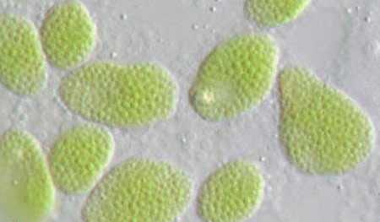

Fig. 1: Ten live epithelial cells of the Malachite Marmoset. Each cell is packed full of green structures

Statistical analysis of organelle size and distributional frequency within 5 serial-sectioned epithelial cells prepared for electron microscopy showed that that cells contained only one organelle of the appropriate size and frequency to be considered as the counterpart of the green structures seen with light microscopy. In fact, apart from the nucleus, no other organelle had an average diameter greater than 2 microns.

The “counterpart” structures each contained many inter-connected stacks of apparently identical sub-units. Within each structure, the stacks are separated by an amorphous matrix (Figs 2-3). High-magnification imaging of the outer membrane of the ChLS’s showed that it was double membrane (Fig. 4). Because of the obvious structural similarities to typical plant chloroplasts, we will refer to the epithelial cell structures as chloroplast-like structures (ChLS’s), the stacks as grana-like structures (GrLS’s), and the GLS sub-units as thylakoid-like structures (TyLS’s).

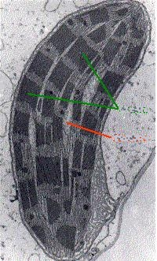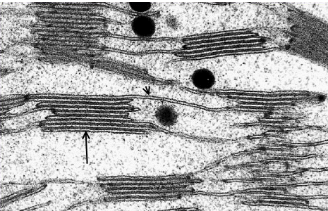

Figs 2-3: The upper figure shows a section through one chloroplast-like structure (ChLS) in the epithelial cell of a Malachite Marmoset. Each contains many interconnected stacks or grana-like structures (GrLS’s, green lines) separated by an amorphous matrix (orange line). The lower figure, at higher magnification, shows that that each GrLS is comprised of many identical membrane-bound sub-units, the thylakoid-like structures (TyLS’s), some of which form interconnecting bridges between stacks. The large arrow indicates one TyLS within a stack, and the small arrow points to a TylS that bridges two stacks.

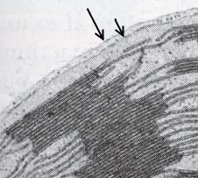

Fig 4: The double outer membrane of a ChLS. The large and small arrows indicate the outer and inner membranes respectively.

Digital reconstruction based on serial sectioning, showed that the each GrLS was discrete, and most were dough-nut shaped (Fig 3), a feature that was not evident in low magnification, live cell microscopy. The hole diameter averaged one third of the total.

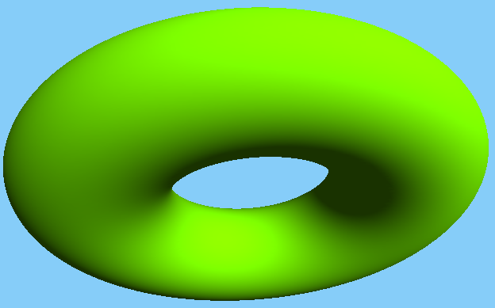

Fig. 5. The toroidal shape of the GrLS’s seen in the epithelial cells of the Malachite Marmoset. Based on digital reconstruction of images from electron microscopical serial sectioning.

(Interpretational Hints: The ultrastructure of the structures is identical to that of typical plant chloroplasts. These contains many interconnected stacks (grana), each composed of identical sub-units (thylakoids), and located within an amorphous matrix (stroma). Chloroplasts also typically have a double outer membrane, thought to be a consequence of their origin as engulfed prokaryotes (Endosymbiont Theory). Mitochondria, also believed to be of prokaryotic origin, also have a double outer membrane. The overall dough-nut shape of the ChLS’s is NOT typical of plant chloroplasts (which are ovoid). Could the dough-nut shape be an artefact of preparation for electron microscopy? If it is real, how relevant is the difference in shape?)

Lack of nucleic acids in the GrLS’s

Prompted by the similarity of the ChLS’s to chloroplasts, we attempted to extract DNA and RNA from them, in order to do a comparative sequence study. However, while the ChLS’s could be easily isolated from a suspension of cultured Malachite Marmoset epithelial cells (using the Sigma-Aldrich Chloroplast Isolation Kit), the attempted protocols for DNA and RNA extraction (Triboush et al., 1998; Fish and Jagendorf,1980) did not yield any NA of any type.

(Interpretational Hints: A. Could the lack of success in finding DNA or RNA be due to the application of plant protocols to animal tissue? Also, the authors only tried ONE protocol for each type of NA. B. Plant chloroplasts are not capable of independent existence, therefore they must have lost DNA and or RNA since the hypothesized endosymbiotic engulfment event, gradually becoming more and more dependent on the host. Perhaps these animal “chloroplasts” have just evolved further.)

A RuBisCO-like protein in epithelial cells

Ovoid patches of fluorescence, between 1-6 microns in diameter, were seen in collected inages (3 micron optical slices) of fixed epithelial cells labelled with a fluoresecently-tagged antibody to the RuBisCO large sub-unit (Fig. 6). Fig. 6 shows a single 3 micron optical slice through one cell. Analysis of entire sets of optical slices from 10 individual cells indicated that the diameter of the fluorescent patches ranged between 4-6 microns.

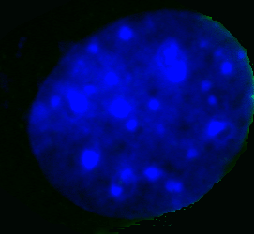

Fig. 6. A single optical slice through a fixed epithelial cell of the Malachite Marmoset labelled with a fluoresecently-tagged antibody to the RuBisCO large sub-unit.

Fractionation of the non-membranous component of isolated ChLS’s yielded two very common proteins, of MW 55kD and 13kD respectively. Analysis of the amino acid sequence of the larger protein demonstrated that 65% homology with the large sub-unit of Form I RuBisCO.

(Interpretational Hints: RuBisCo in plants is composed of large and small sub-units , nd its most typical form is called Form I. How meaningful is 65% homology?How does the evolutionary distance between plants and animals affect our interpretation? In plants the large sub-unit is coded by nuclear DNA, and the small by chloroplast DNA. How does the possibility that the Marmoset ChLS may have no DNA affect our interpretation?

Discussion: To be added by you!

Glossary:

AUTOTROPH: An autotroph (from the Greek autos = self and trophe = nutrition) is an organism that produces complex organic compounds from simple inorganic molecules and an external source of energy, such as light or chemical reactions of inorganic compounds.

ENDOSYMBIONT THEORY: The endosymbiont theory attempts to explain the origins of organelles such as mitochondria and chloroplasts in eukaryotic cells. The theory proposes that chloroplasts and mitochondria evolved from certain types of bacteria that prokaryotic cells engulfed through endophagocytosis. These cells and the bacteria trapped inside them entered a symbiotic relationship, a close association between different types of organisms over an extended time. However, more specifically, the relationship was endosymbiotic, meaning that one of the organisms (the bacteria) lived within the other (the prokaryotic cells).

HETEROTROPH: A heterotroph is known as a consumer in the food chain. Contrast with autotrophs which use inorganic carbon dioxide or bicarbonate as sole carbon source. All animals are heterotrophic, as well as fungi and many bacteria. Some parasitic plants have also turned fully or partially heterotrophic, whereas carnivorous plants use their flesh diet to augment their nitrogen supply, but are still autotrophic.

RuBisCO: Ribulose-1,5-bisphosphate carboxylase/oxygenase, most commonly known by the shorter name RuBisCO, is an enzyme (EC 4.1.1.39) that is used in the Calvin cycle to catalyze the first major step of carbon fixation, a process by which the atoms of atmospheric carbon dioxide are made available to organisms in the form of energy-rich molecules such as sucrose. RuBisCO catalyzes either the carboxylation or oxygenation of ribulose-1,5-bisphosphate (also known as RuBP) with carbon dioxide or oxygen.
RuBisCO is very important in terms of biological impact because it catalyzes the most commonly used chemical reaction by which inorganic carbon enters the biosphere. RuBisCO is apparently the most abundant protein in leaves, and it may be the most abundant protein on Earth [2] . Given its important role in the biosphere, there are currently efforts to genetically engineer crop plants so as to contain more efficient RuBisCO (see below). Structure: In plants, algae, cyanobacteria, and phototropic and chemoautotropic proteobacteria the enzyme usually consists of two types of protein subunit, called the large chain (L, about 55,000 Da) and the small chain (S, about 13,000 Da) [3] . The enzymatically active substrate (ribulose 1,5-bisphosphate) binding sites are located in the large chains that form dimers as shown in Figure 1 (above, right) in which amino acids from each large chain contribute to the binding sites. A total of eight large chain dimers and eight small chains assemble into a larger complex of about 540,000 Da [4] . In some proteobacteria and dinoflagellates, enzymes consisting of only large subunits have been found [5] .

THYLAKOID: A Thylakoid is a membrane-bound compartment inside chloroplasts and cyanobacteria. They are the site of the light-dependent reactions of photosynthesis. The word "thylakoid" is derived from the Greek thylakos, meaning "sac". Thylakoids consists of a thylakoid membrane surrounding a thylakoid lumen. Chloroplast thylakoids frequently form stacks of disks referred to as "grana" (singular: granum). "Grana" is Latin for "stacks of coins". Grana are connected by intergrana or stroma thylakoids, which join granum stacks together as a single functional compartment.

